Problem 1

Part A: Code

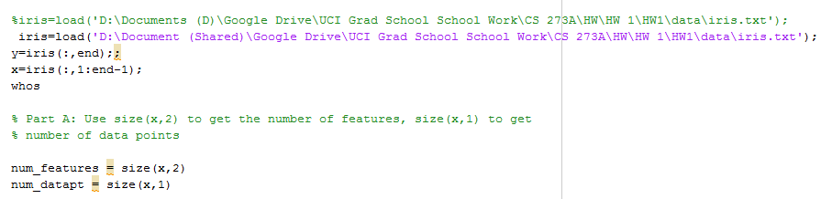

Result:

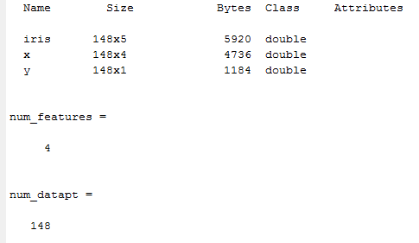

Part B (Histogram Plot for each features)

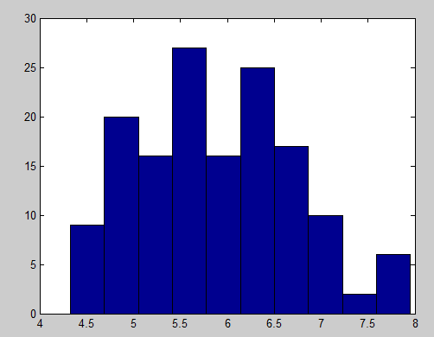

Histogram of Feature 1

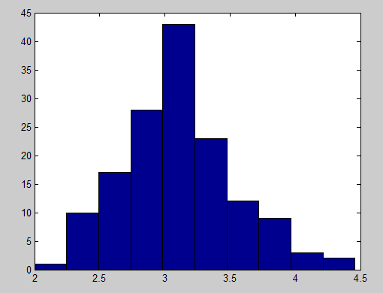

Histogram of Feature 2

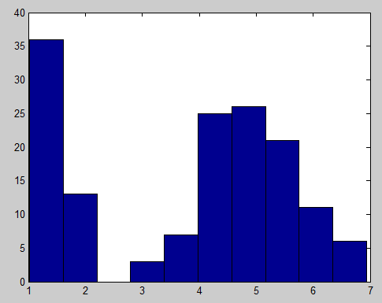

Histogram of Feature 3

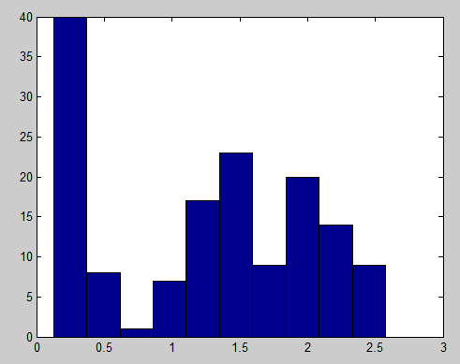

Histogram of Feature 4

Part C (mean of each features)

Code:

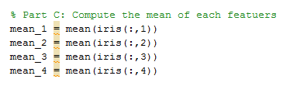

Result:

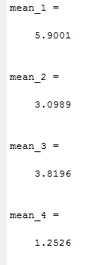

Part D: Variance and Standard Deviation of each features

Code:

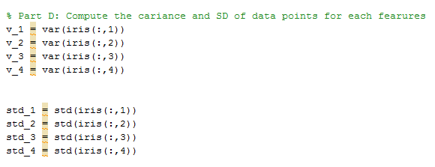

Result:

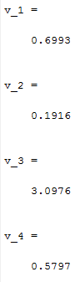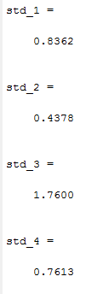

Part E: Normalize Data

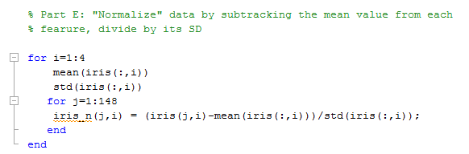

Normalized Data and pre-normalized data share the same distribution. For details, please see the distribution plot in MATLAB code (figure 6-13)

Example: Features 1 and Normalized Features 1

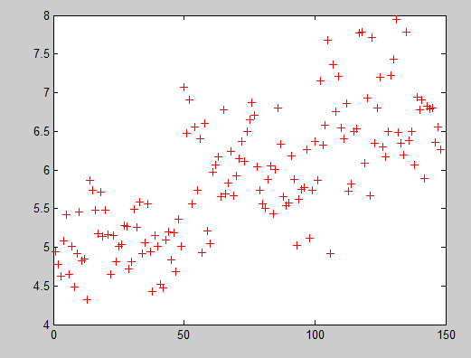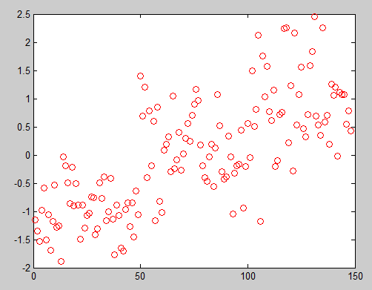

Part F: Plot Features (1,2) (1,3) and (1,4)

Code:

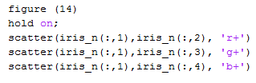

Features (1,2) is plotted in red; Features (1,3) is plotted in greed; Features (1,4) is plotted in blue

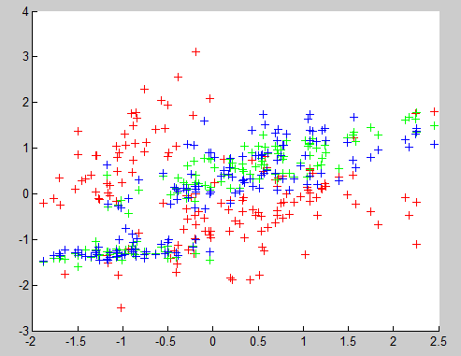

Problem 2

Part A: Visualize the classification boundary for varying values of K

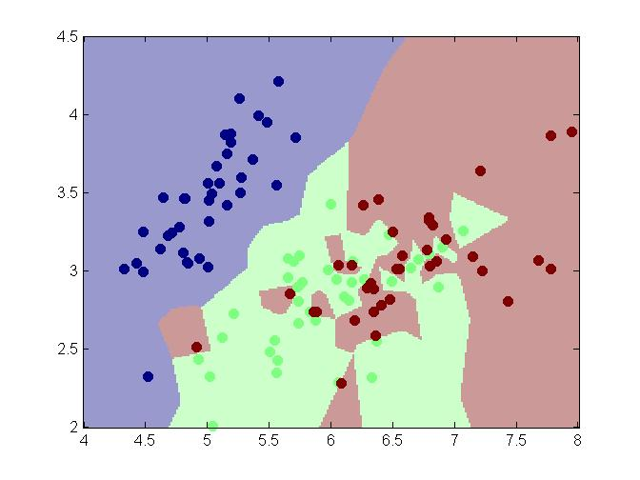

Figure 1 (K = 1)

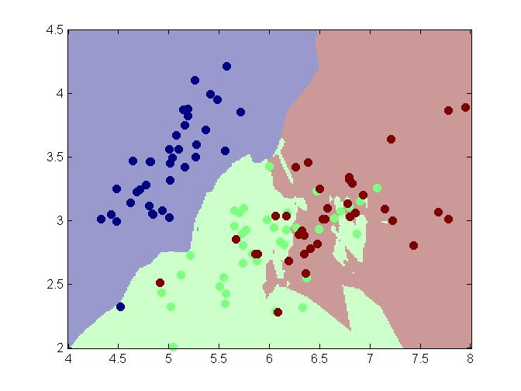

Figure 2 (K = 5)

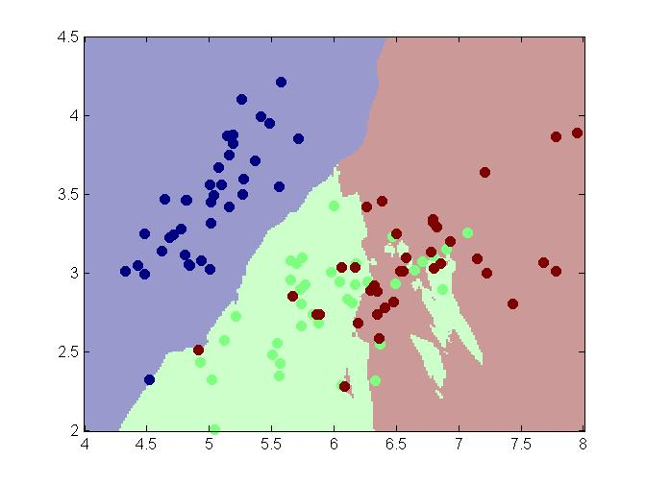

Figure 3 (K = 10)

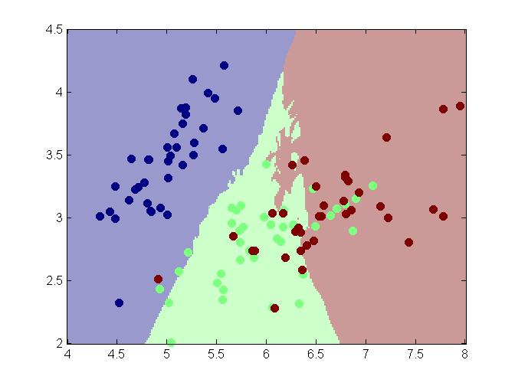

Figure 4 (K = 50)

Part B: Visualize the classification boundary for varying values of K

Code:

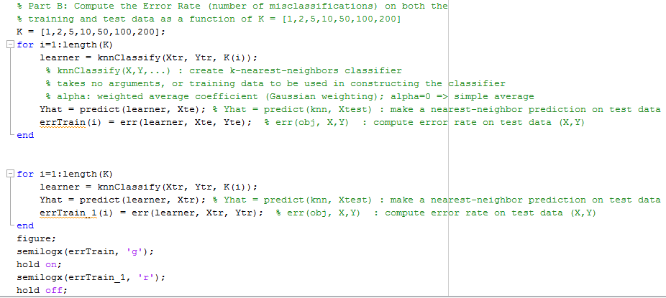

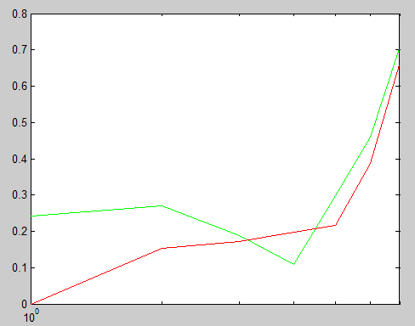

Problem 3: Please see the picture attached below

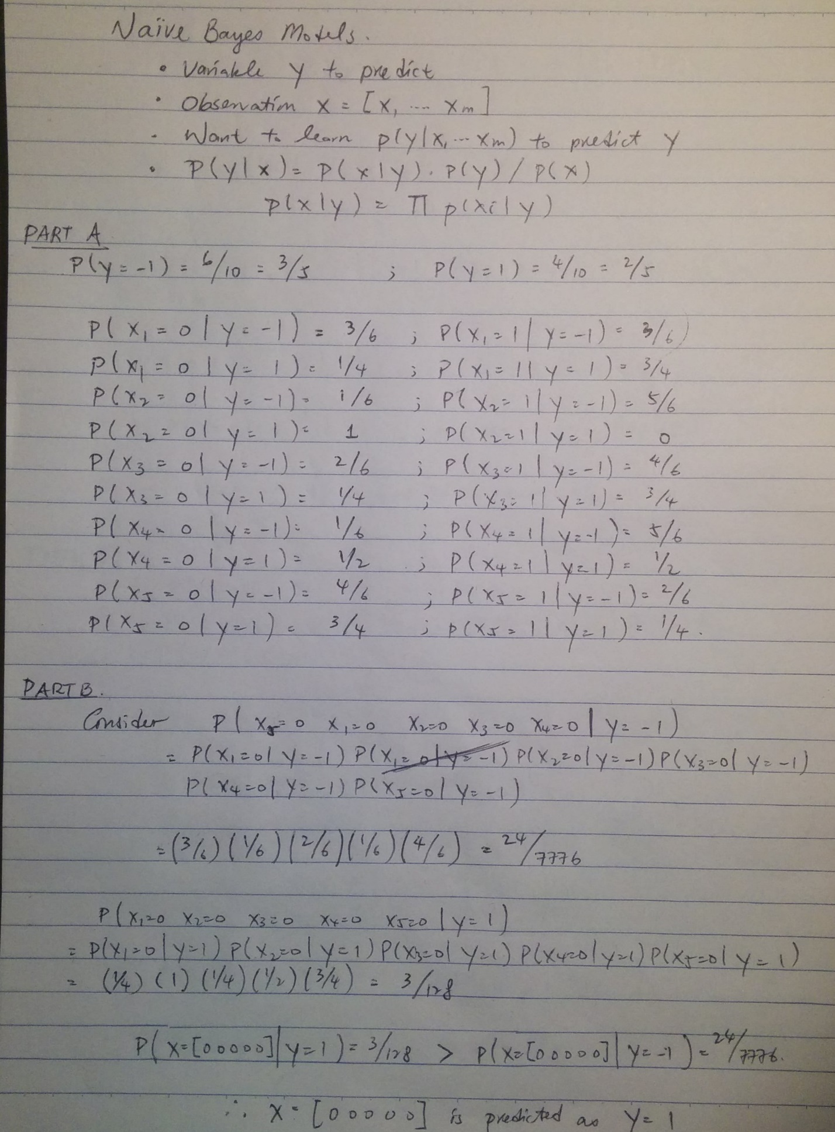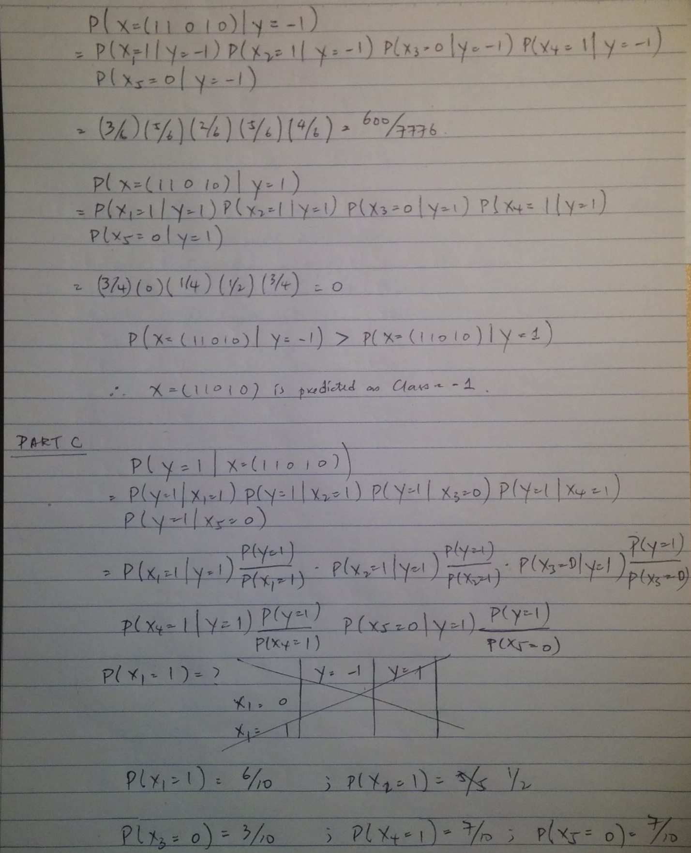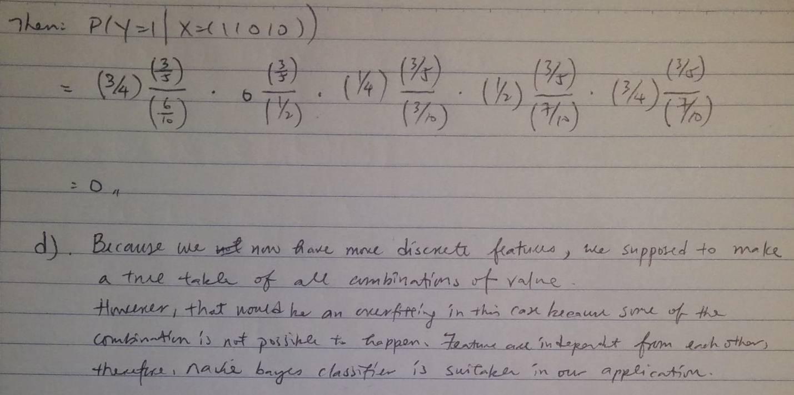

Problem 4

Part A: Splitting and find mean and cov

Code:

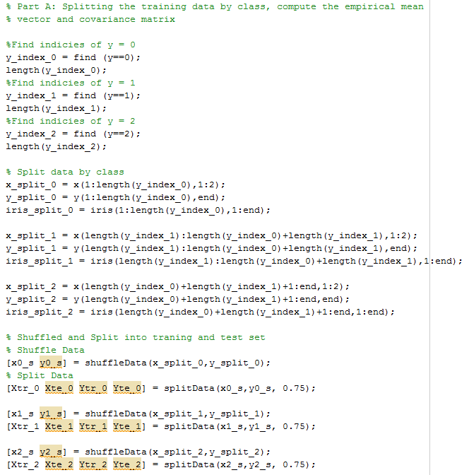

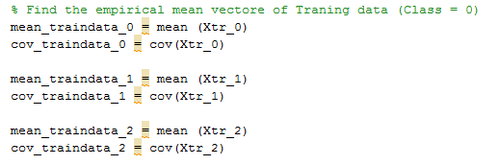

Result:

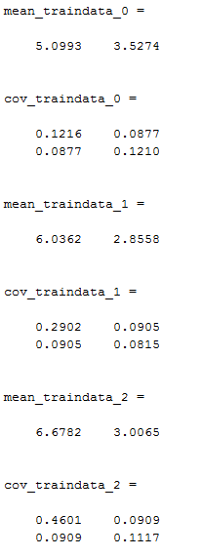

Part B: Code

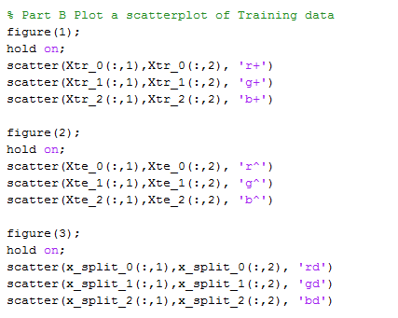

Plot:

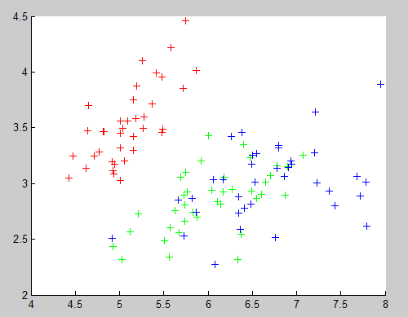

Figure of Train Data for each class

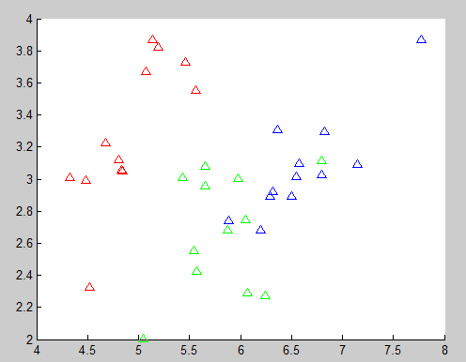

Figure of Test Data Plot

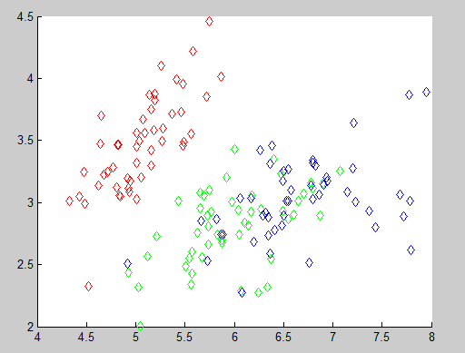

Figure of all data point for each class (Train and Test)

Part C

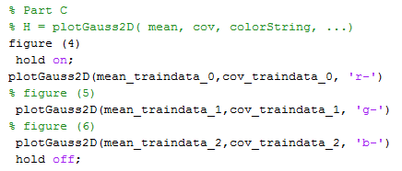

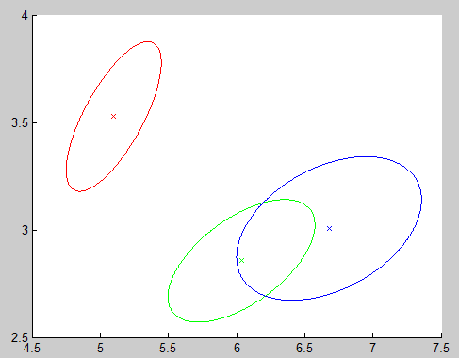

Part D and E

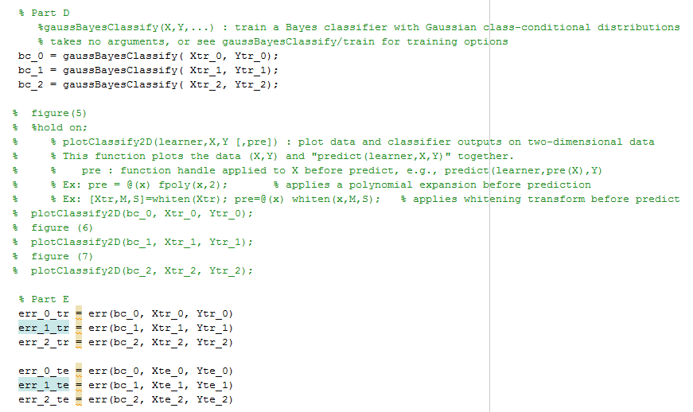

Result:

